|  |  |  |  |  |  |  |  |  |  |  |  |  |
| --- | --- | --- | --- | --- | --- | --- | --- | --- | --- | --- | --- | --- |
|  |  |  |  |  |  |  |  |  |  |  |  |  |

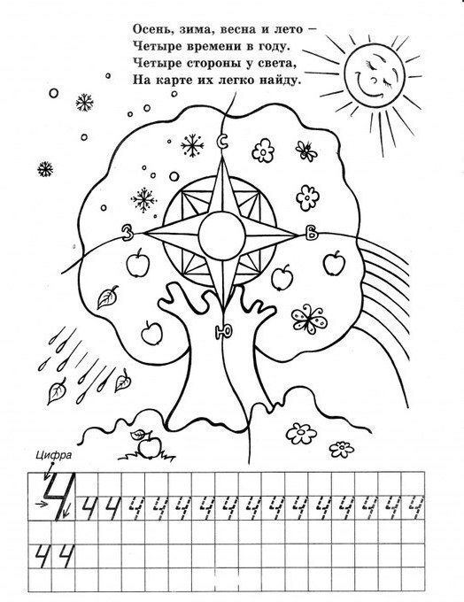Вагон №

**Билет (детский) зубрицкий в.**

**по маршруту «Школа – Математика»**

1.

|  |  |  |  |  |  |  |  |  |  |  |  |  |  |  |  |  |
| --- | --- | --- | --- | --- | --- | --- | --- | --- | --- | --- | --- | --- | --- | --- | --- | --- |
| 0 |  | 4 |  | 8 |  |  |  |  | 2 | 0 |  |  |  |  |  |  |

2.

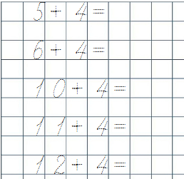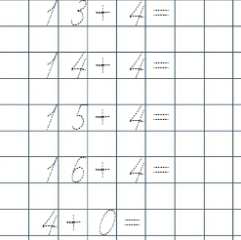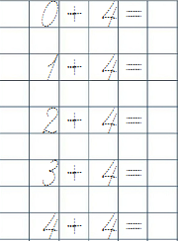3.

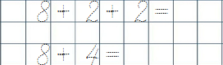4.



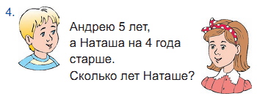

5.

Андрей

|  |  |  |  |  |  |  |  |
| --- | --- | --- | --- | --- | --- | --- | --- |
|  |  |  |  |  |  |  |  |

Наташа

В первый день белка нашла 10 орехов, а во второй – на 4 ореха больше. Сколько орехов нашла белка во второй день?

В I день – _____ орехов

Во II день – ? , на ____ ореха больше



                    
                    
                    

